https://www.kaggle.com/datasets/ramjasmaurya/medias-cost-prediction-in-foodmart

*This dataset can be used to predict the cost of a media campaigns for acquiring new customers for a supermarket based on several characteristics of the consumer (like number of children, number of cars,..) and the location (the store sales, store area,...). It has 40 columns.*

____________________________________________________________________________________

1/3 of customer lifetime value, depending on the market segmentation

Customer Lifetime Value/costumer acquisition cost

**1st step : by sunday night // Keep context for the presentation**

*Look for relevant predictors / factors / demographics that affect the shopping behavior of consumers by the end of the week end and list them (with references maybe to keep track) here:*

* [*https://www.mckinsey.com/capabilities/growth-marketing-and-sales/our-insights/the-great-consumer-shift-ten-charts-that-show-how-us-shopping-behavior-is-changing*](https://www.mckinsey.com/capabilities/growth-marketing-and-sales/our-insights/the-great-consumer-shift-ten-charts-that-show-how-us-shopping-behavior-is-changing) *Study on how US shoppings trends have changed : (lots of graphs that can be used to put a context to our study and why we decide to focus on some predictors or on some models more than others.* 
  + *Digital Shopping is here to stay*
  + *Millenials and high income earners are in the lead to shop online*
  + *Consumers are switching brands at unprecedented rates (36% of consumers try new product)*
  + *Consumer shopping intent is focused on essentials*
* <https://www.epsilon.com/us/insights/blog/5-ways-consumer-shopping-behavior-has-transformed-in-the-past-2-years> other study on trends in the shopping:
  + Consumers are still buying non-essential items
  + Shoppers are trying new brands
  + Online shopping is here to stay
* Google study with some statistic <https://www.thinkwithgoogle.com/consumer-insights/consumer-trends/us-shopping-behavior-statistics/> (more global statistics not so much information on the demographic but still interesting)
* Some good graphs about men of women preferences when it comes to shopping : https://delighted.com/blog/us-trends-online-vs-in-store-shopping

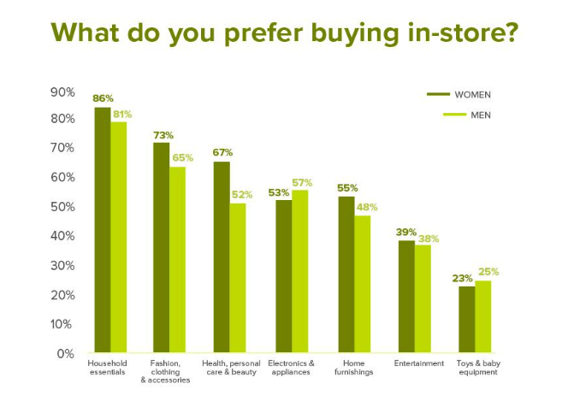

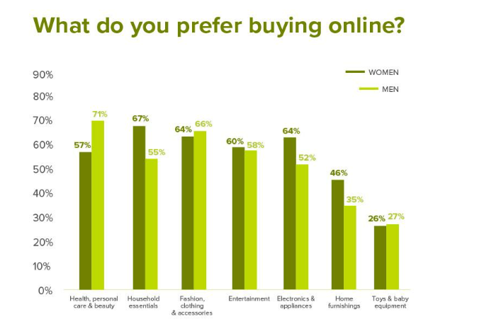

* Generation shopping habits <https://salesfloor.net/blog/generations-shopping-habits/> :
  + Baby boomer : convenience above all, generation too stressed for shopping trips. Spending power to make purchases without necessarily hunting down for bargains in store. Can shop online but 84% prefer to shop in-store.
  + Generation X: represents 31% of US total income, do research before buying a product? Trusts clienteling techniques, digital email is one of the best channels for reaching out to this generation, respond well to personalized offers based on their previous purchases.
  + Generation Y : even they shop online and in-store, more likely to purchase in store than online. Selectives with their purchase. 82% of Millennials say word-of-mouth is a key influencer of their purchase decisions. 68% said being strongly influenced by social media. 90% of millenials to research online before buying
  + Gen Z : Use google to compare everything, more slective when it comes to big expenditures (buying product only when they’re on sale). For 84% of Gen Z, shopping is a social activity. Still prefer to buy in-store than online

**2nd step : split work and start draft (monday ?)**

Outline

* Introduction *(a paragraph to give the story & context – Lucie & Julie)*
* What do we fix? Problem statement [Use Case] *(one or two sentences – Julie & Lucie)*
  + Customers who spend more
* Why do we do it? Business Value [Objectives + Desired Outcome] *(2 paragraphs – Emery's)*
* How do we do it? [Solutions] *(one paragraph – Data Sci Team @Raman)*
* Results & Interpretation *(to be included in the notebook – Business Ana Team converts into business insights)*
* Conclusion *(depending on results and visualizations)*
* Attachments

I started a new draft here: https://mcgill-my.sharepoint.com/personal/julie_chanzy_mail_mcgill_ca/_layouts/15/doc.aspx?sourcedoc={64e2f618-ca17-414a-91b3-ca497e770cc8}&action=edit

**3rd step : draft**

Check-point on Friday 10 by noon

Start presentation slides during the week-end : structure & split > meeting on Saturday

1. Introduction (context, storytelling)
2. Problem statement (use case)
3. Objectives (3)
4. Data sci contribution
5. Data an contribution
6. Business an insights
7. Final recommendation

Focus on targeting the customer based on the acquisition cost > focus on the segment that spends the most

What are the predictors

Example : <https://github.com/McGill-MMA-EnterpriseAnalytics/Anime-Rating-Prediction-and-Recommendation>